10th October 2017

Today my goal is working further on the derivation/theory of my modified ICA for lead guitar. My first step is to see how I could force the components to be dead centre in the stereo spectrum (a rule of thumb suggests the lead guitar should be here).

Looking at the centre of the stereo spectrum and the ICA equation 
I see that if a source is in the centre of the stereo spectrum (assuming  consists of two mixture, one for each of the left and right speaker). In this case, if we assume source 1 (the first column of ) is the lead guitar, then that column in A would have both values the same (if we were being picky, this value should be 0.5, however I will generalise here). Looking at the matrix inverse for a matrix where the first column has the same values (let us call that value ), then the inverse becomes of the form:

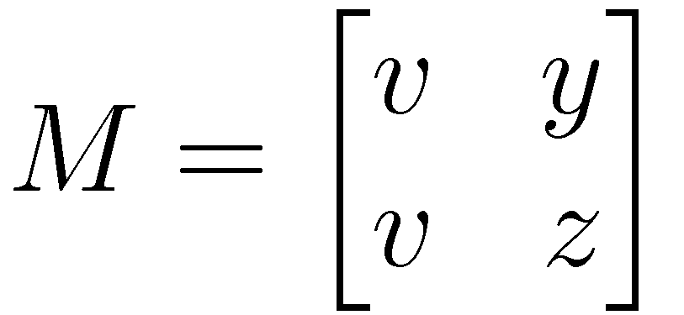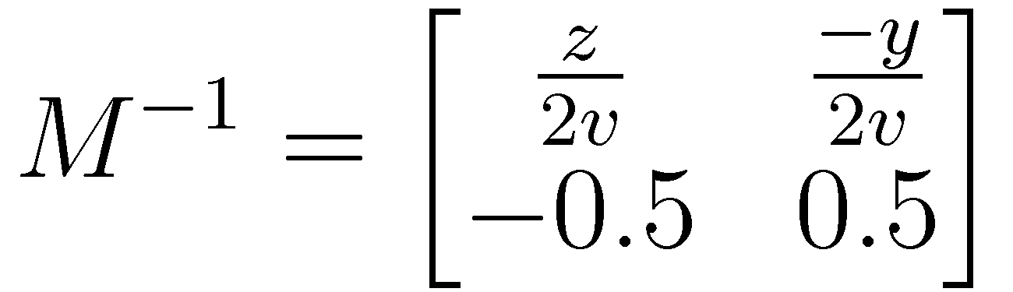

So, if we are in a situation where we want 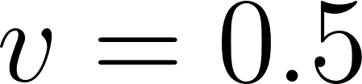, then all we need to constrain is that 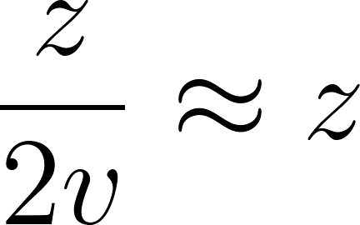 and 